The Colour Monster

The Colour Monster is all mixed up!

Can you help the Colour Monster by using the tweezers to help him to organise his feelings?

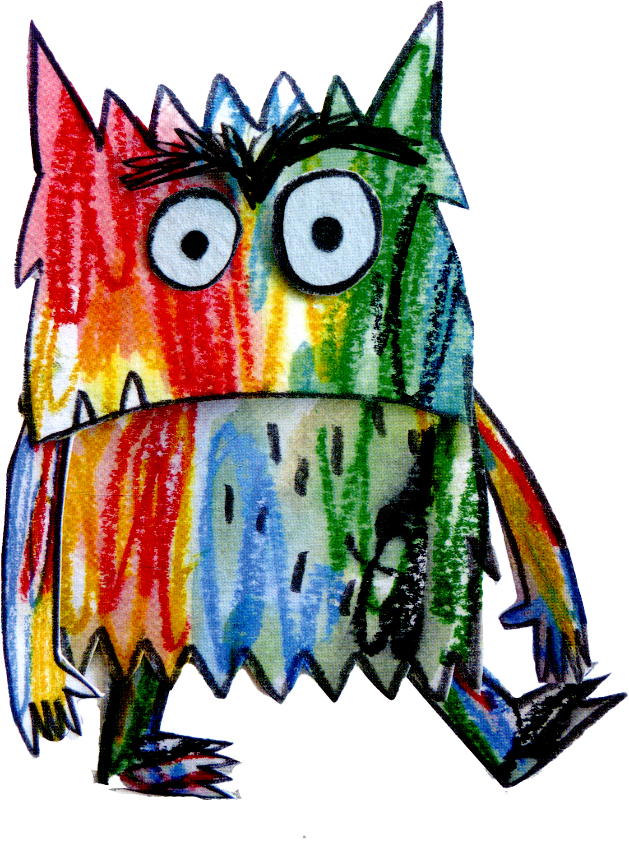

Whilst you are sorting the feelings, have a think…

Have you ever felt each emotion before?

What made you feel that way?

How are you feeling now?

Mindful Colouring

How can colouring be used as a tool for promoting mental wellbeing in children?

1. **Stress Reduction:** Colouring relaxes the mind, easing stress often associated with managing these conditions.
2. **Distraction Technique:** It provides a positive distraction from discomfort, helping children focus on something enjoyable.
3. **Expression of Creativity:** Colouring boosts self-esteem and fosters a positive mindset through creative expression.
4. **Mindfulness Practice:** Encourages mindfulness, helping children stay present and cope with challenges.
5. **Sense of Control:** Gives children a sense of control over their creative expression, empowering them.

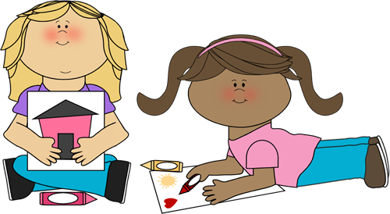

Parents, feel free to get stuck in with some mindful colouring too!

Free From Dough

Please find the full list of dough ingredients on the chalkboard in the tuff tray. There are many reasons why using modelling dough can be beneficial for children managing allergies, asthma, and eczema:

1. **Sensory Exploration:** It can soothes discomfort through tactile stimulation.
2. **Stress Relief:** Kneading and shaping play dough can help children to relax
3. **Creativity:** Allows for joyful self-expression and accomplishment.
4. **Distraction:** Can provide a positive escape from health worries.
5. **Social Interaction:** Encourages bonding and reduces feelings of isolation.

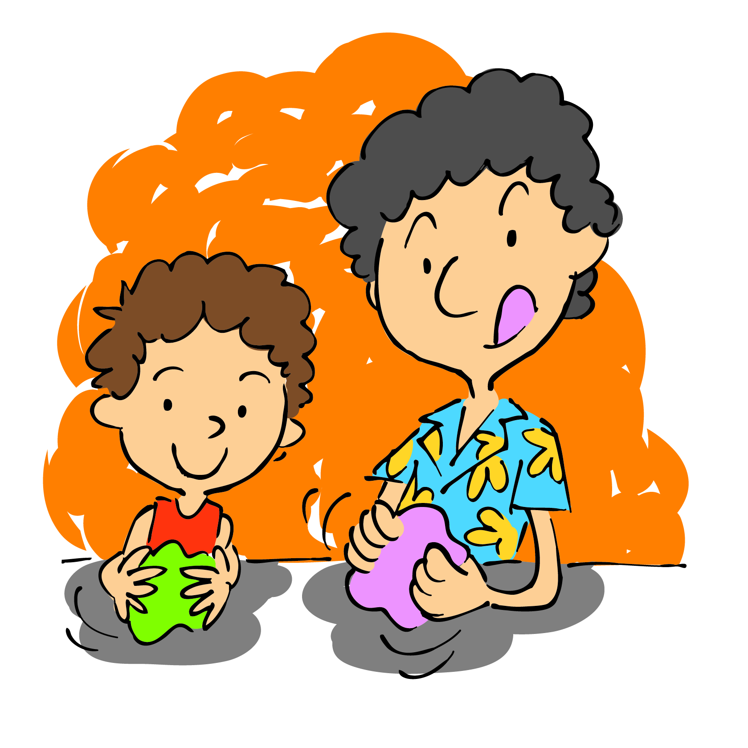

Positive Affirmation Pebbles

Positive Affirmation Pebbles can boost self-esteem and resilience in children and those managing health challenges.

1. **Boosting Self-Esteem:** Affirmations help build confidence.
2. **Empowerment:** They focus on strengths, empowerment
3. **Stress Reduction:** Positive self-talk reduces stress.
4. **Sense of Control:** Selecting relevant affirmations can help to gain control over thoughts.
5. **Reminder of Positivity:** Pebbles provide tangible reminders of resilience.

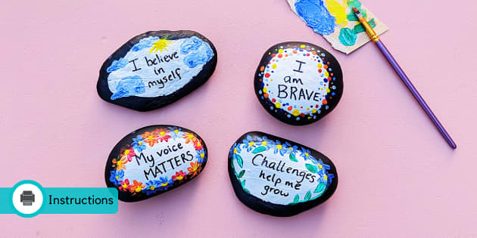

Positive affirmations on pebbles are a wonderful thing to give to someone else who may be needing some extra encouragement. They are also great for keeping in pockets as a little reminder of everything that you can achieve, overcome and how resilient you are.

Yoga

According to the National Institute of Health, ‘Yoga with children can allow them to redirect energy positively, helping them calm their minds and bodies, especially during anxiety periods. It may be helpful for those who can be destructive and aggressive. Yoga may increase a child's well-being, enhance self-worth, and promote fewer negative behaviours.’

Children managing chronic health conditions, like allergies, asthma and eczema, can sometimes see an impact on their mental health. Yoga can help to reduce anxiety and stress and can build self-esteem as well as being a fun activity for all children to join in with.

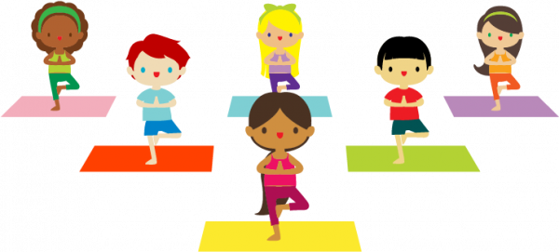

Follow the cards and see what interesting yoga poses you can put into practice.

Breathing Wand

According to the Mayo Clinic, ‘deep breathing techniques can take you from an excited state of mind with the “fight or flight” instinct on high alert to a state where heart rate slows, blood pressure goes down and pain decreases.’

Sometimes, managing allergies, asthma and eczema can feel a little overwhelming and cause worry and anxiety. Deep breathing can help us to feel calmer and more relaxed and can even help to ease pain, like headaches.

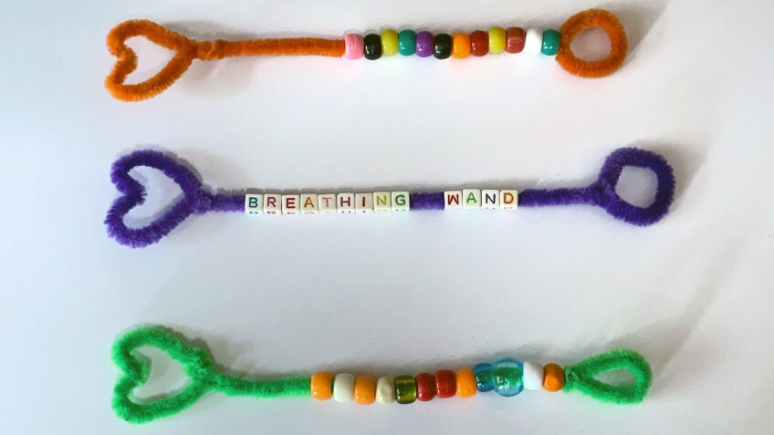

Tools like breathing wands can help us in many ways with deep and controlled breathing. They can be used as a physical reminder to breathe deeply as well giving us something to focus on and allowing us to count our breaths.